**PHASE 5**

**LESSON 4**

**PRACTICE ASSISTED 4**

**Container scaling with docker swarm**

**CODE:**

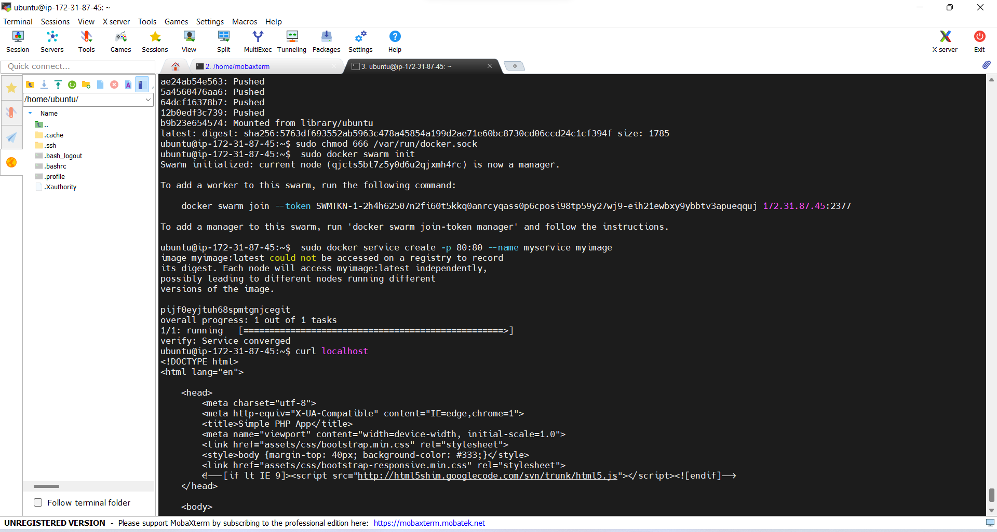

**OUTPUT:**

